I
n this session we will look at what are the ways to handle error and how can we handle errors ?.

Following are the way to handle exception through process.

Camunda Error Handling

- Catch Exception and use Data Based XOR-Gateway
- BPMN Error event
- BPMN Compensation and business transactions

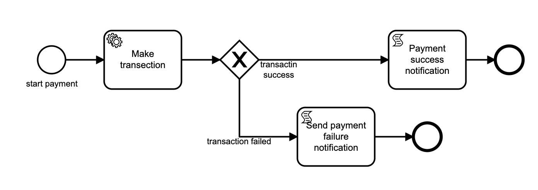
- Catch Exception and use Data Based XOR-Gateway

Id: payment-processs
Name: payment process

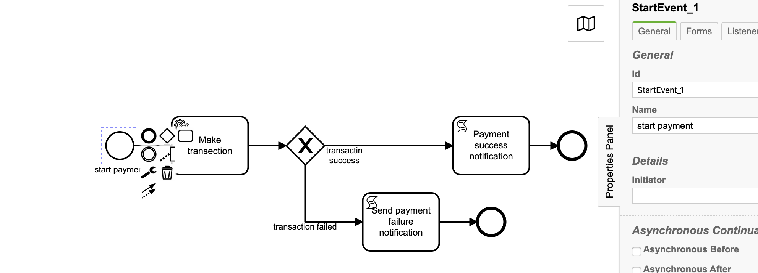
Start event: start payment
Id: StartEvent_1
Name: start payment

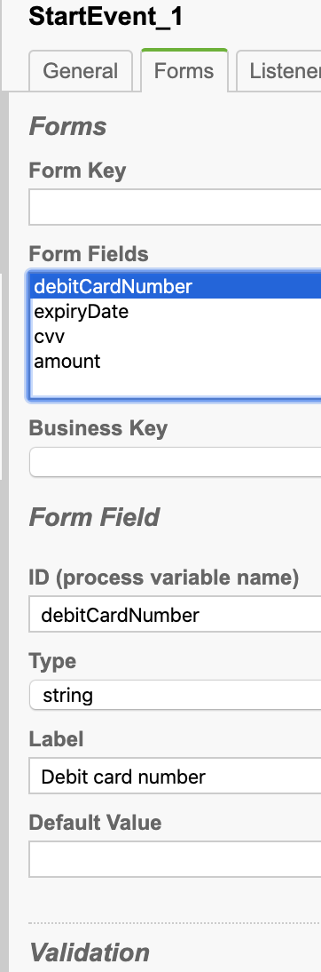
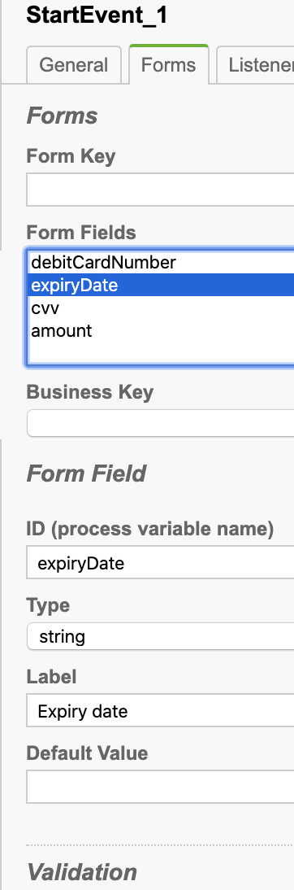
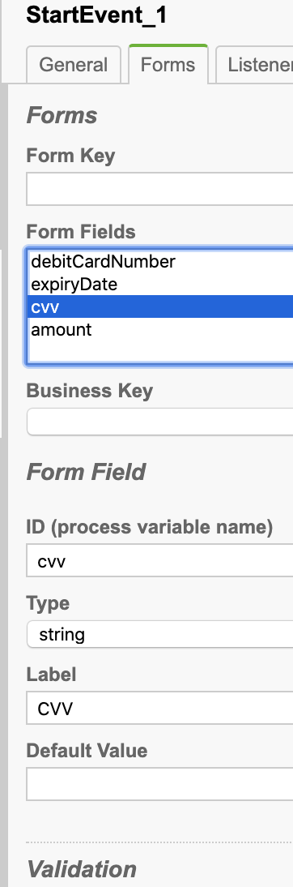
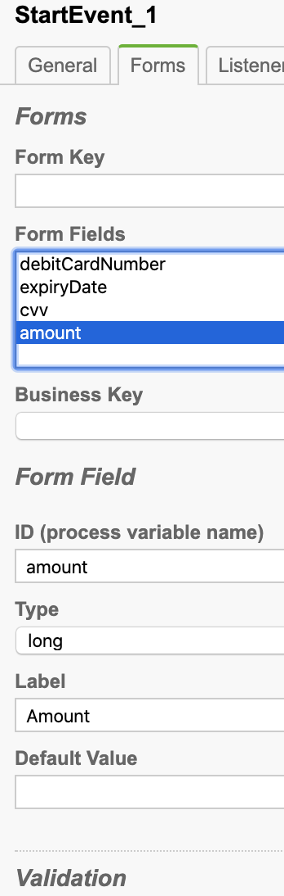
Start event form:
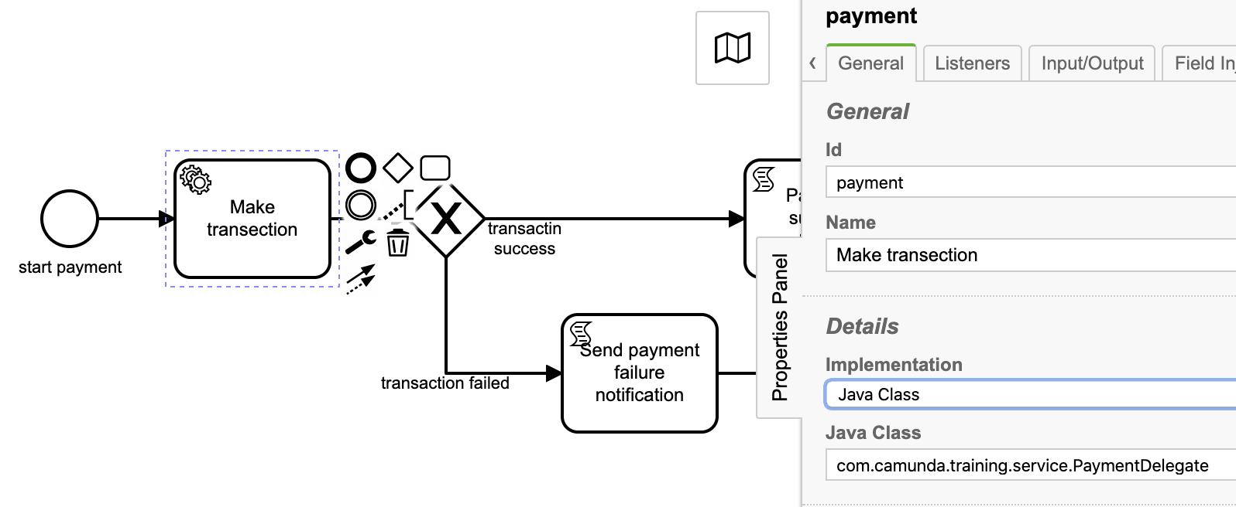
Service task: Make transection

Id: payment
Name: Make transection
Implementation: Java Class
Java Class: com.camunda.training.service.PaymentDelegate

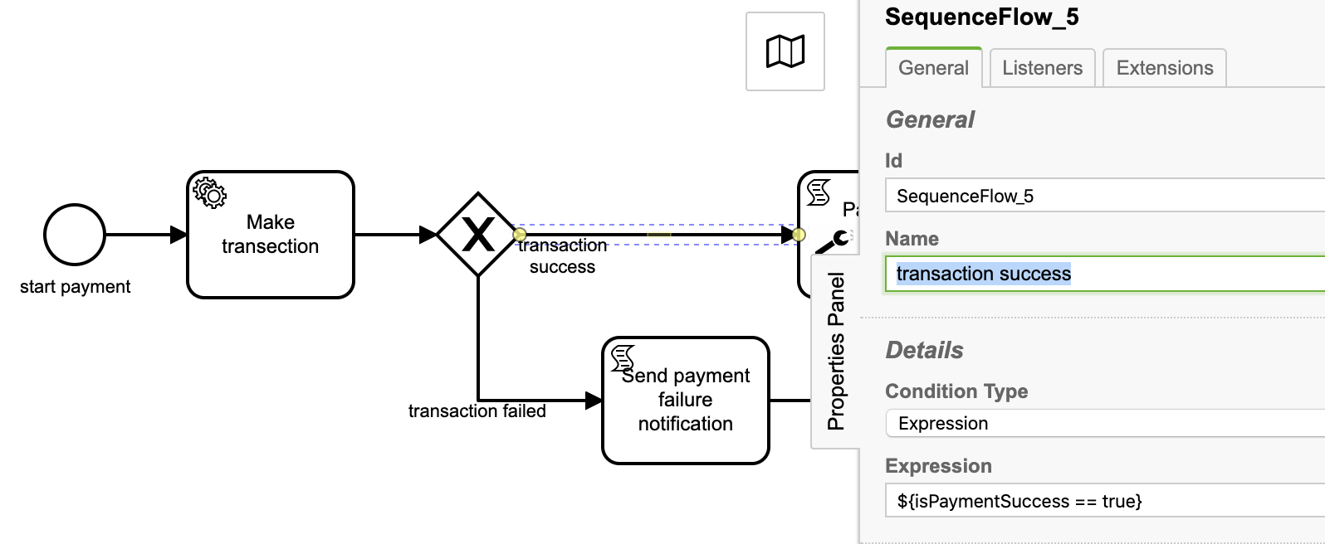
Sequence flow constraint: transaction success

Id: SequenceFlow_5
Name: transaction success
Condition Type: Expression
Expression: ${isPaymentSuccess == true}

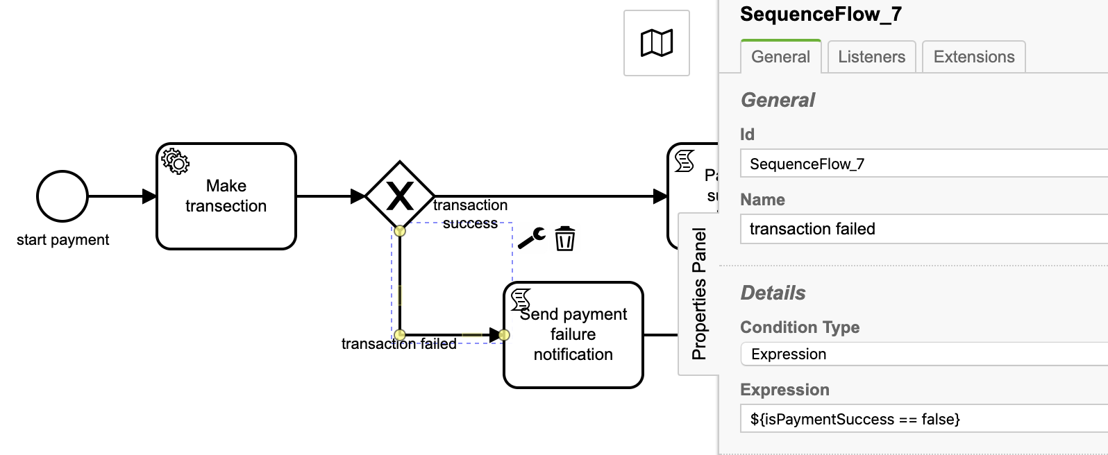
Sequence flow constraint: transaction failed
Id: SequenceFlow_7
Name: transaction failed
Condition Type: Expression
Expression: ${isPaymentSuccess == false}
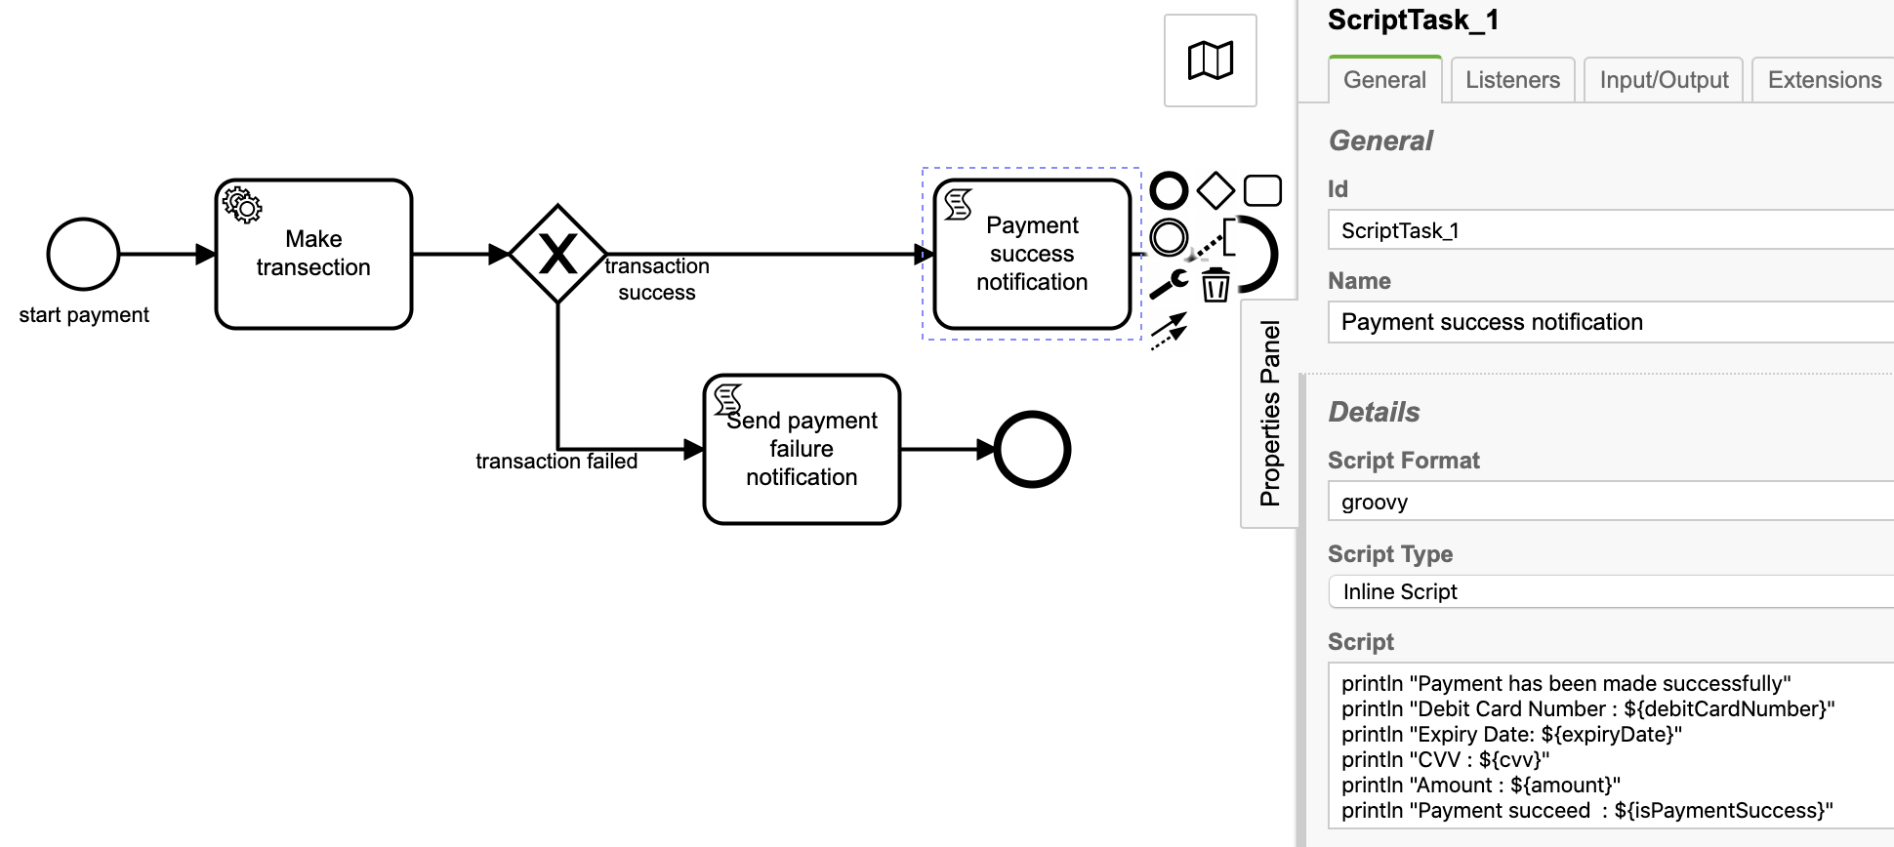
Script task: Payment success notification
Id: ScriptTask_1
Name: Payment success notification
Script Format: groovy
Script Type: Inline Script
Script:
println "Payment has been made successfully"
println "Debit Card Number : ${debitCardNumber}"
println "Expiry Date: ${expiryDate}"
println "CVV : ${cvv}"
println "Amount : ${amount}"
println "Payment succeed : ${isPaymentSuccess}"
Script task: Send payment failure notification

Id: ScriptTask_2
Name: Send payment failure notification
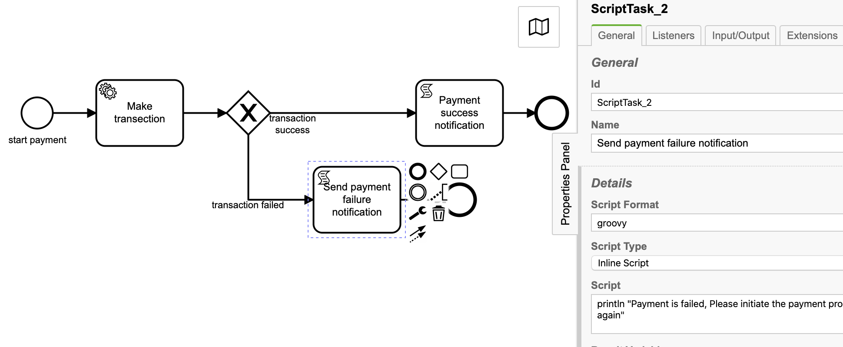
Script Format: groovy
Script Type: Inline Script
Script:
println "Payment is failed, Please initiate the payment process again"

Service task implementation: PaymentDelegate.java
package com.camunda.training.service;

import java.util.logging.Logger;

import org.camunda.bpm.engine.delegate.DelegateExecution;
import org.camunda.bpm.engine.delegate.JavaDelegate;

public class PaymentDelegate implements JavaDelegate {

private final Logger LOGGER = Logger.getLogger(PaymentDelegate.class.getName());

@Override
public void execute(DelegateExecution execution) throws Exception {
String debitCardNumber = (String) execution.getVariable("debitCardNumber");
String expiryDate = (String) execution.getVariable("expiryDate");
String cvv = (String) execution.getVariable("cvv");
Long amount = (Long) execution.getVariable("amount");

LOGGER.info("debitCardNumber : " + debitCardNumber);
LOGGER.info("expiryDate : " + expiryDate);
LOGGER.info("cvv : " + cvv);
LOGGER.info("amount : " + amount);

LOGGER.info("Error occured or payment failed");

execution.setVariable("isPaymentSuccess", Boolean.FALSE);
}
}

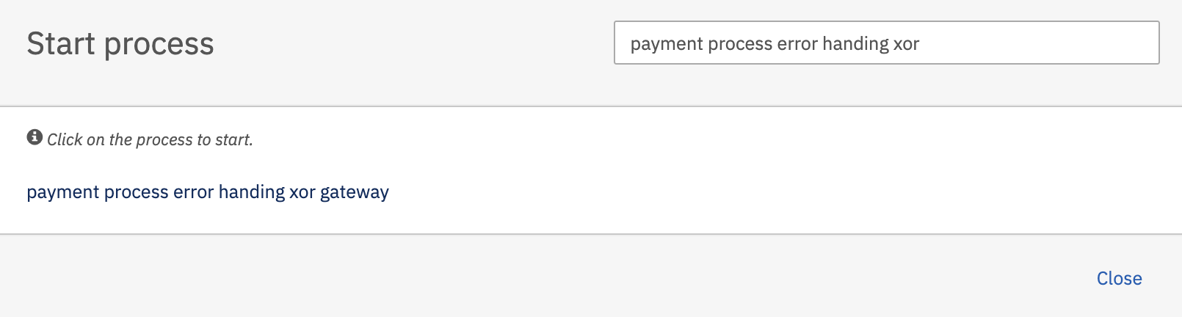
Deploy the process application and start process

Hit the payment process error handling xor gateway, Start process form will open.
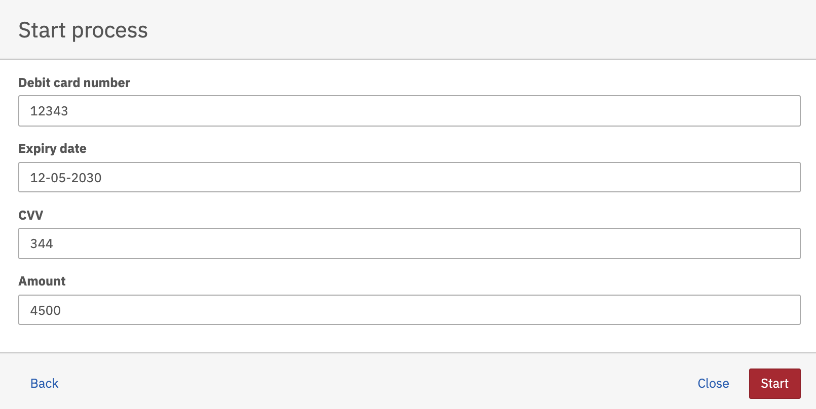

Fill-up the form and hit the Start button.

Observe the tomcat console

06-Sep-2020 21:40:28.106 INFO [http-nio-8081-exec-112] com.camunda.training.service.PaymentDelegate.execute debitCardNumber : 12343
06-Sep-2020 21:40:28.106 INFO [http-nio-8081-exec-112] com.camunda.training.service.PaymentDelegate.execute expiryDate : 12-05-2030
06-Sep-2020 21:40:28.107 INFO [http-nio-8081-exec-112] com.camunda.training.service.PaymentDelegate.execute cvv : 344
06-Sep-2020 21:40:28.107 INFO [http-nio-8081-exec-112] com.camunda.training.service.PaymentDelegate.execute amount : 4500
06-Sep-2020 21:40:28.107 INFO [http-nio-8081-exec-112] com.camunda.training.service.PaymentDelegate.execute Error occured or payment failed
Payment is failed, Please initiate the payment process again

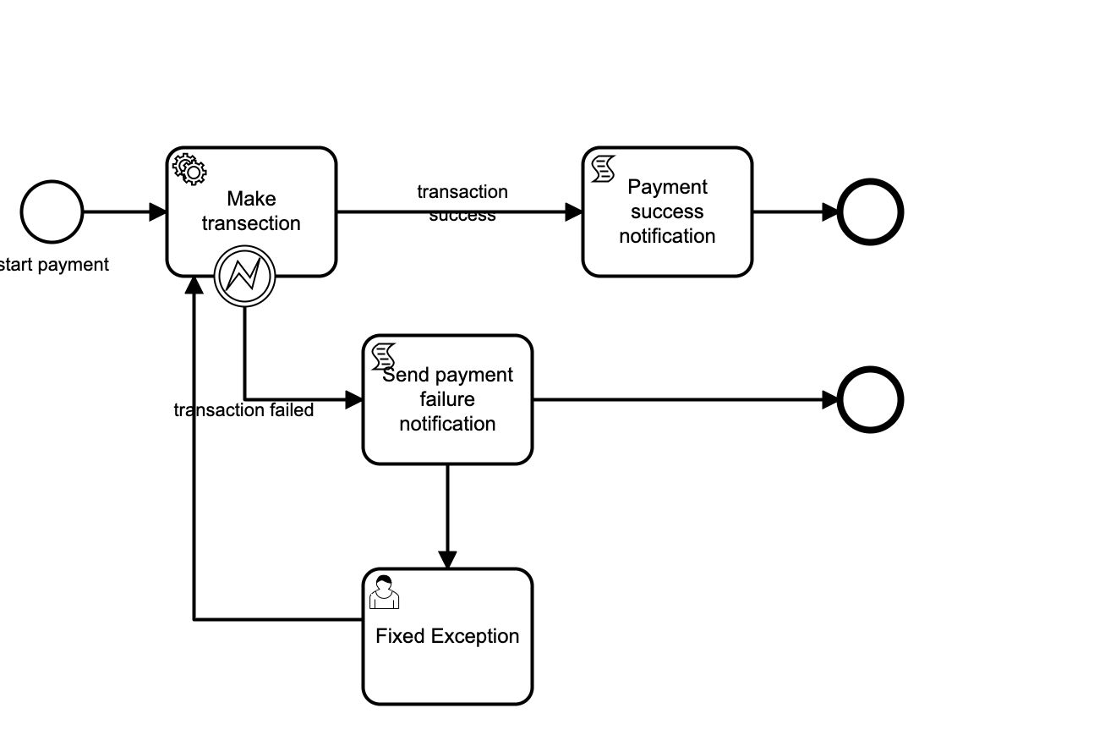
- Catch Exception and use BPMN error

Id: payment-processs-bpmn-error
Name: payment process error handing bpmn error

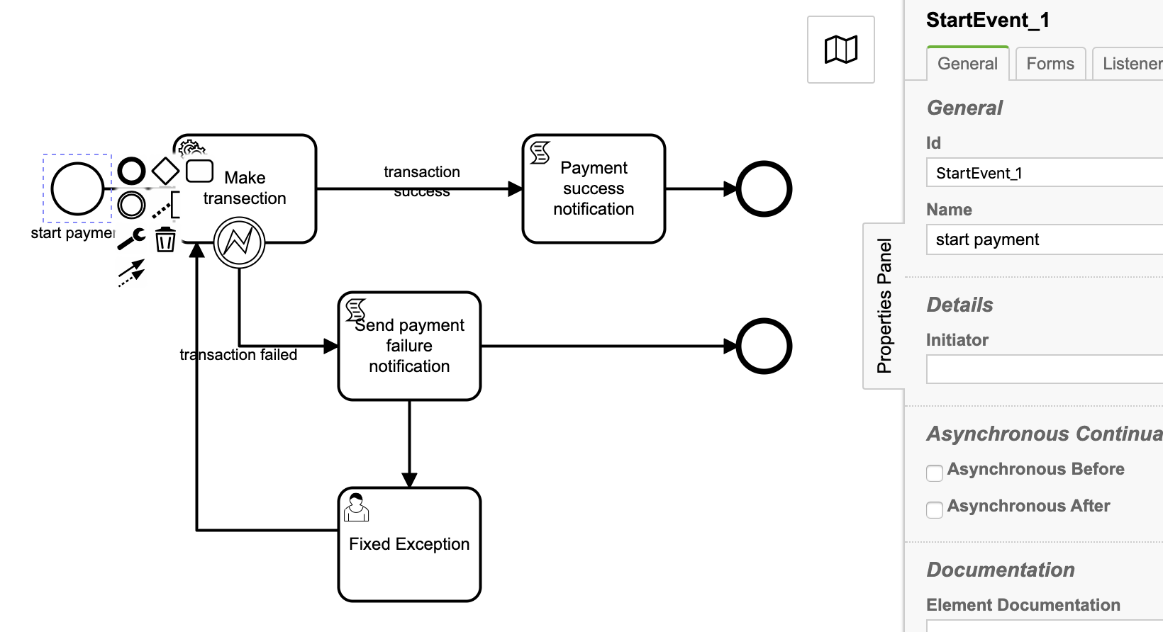
Start event: start payment
Id: StartEvent_1
Name: start payment





Start event form:

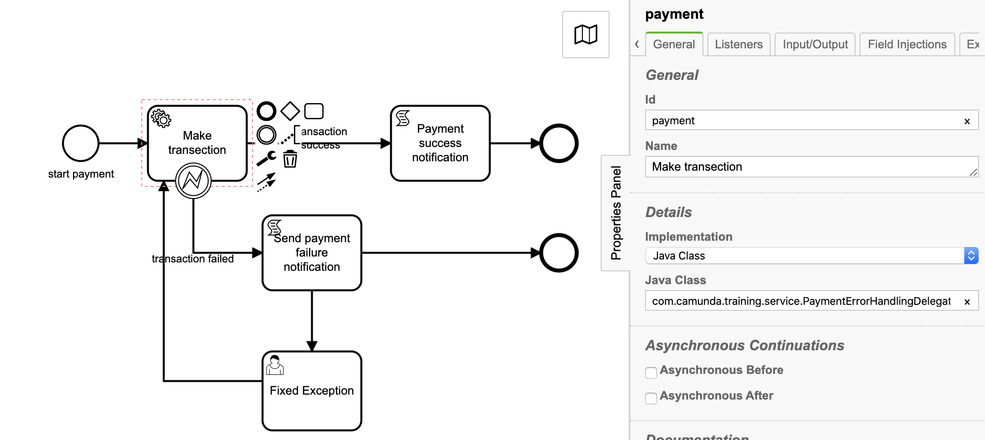
Service task: Make transection

Id: payment
Name: Make transection
Implementation: Java Class
Java Class: com.camunda.training.service.PaymentErrorHandlingDelegate

PaymentErrorHandlingDelegate.java
package com.camunda.training.service;

import java.util.logging.Logger;

import org.camunda.bpm.engine.delegate.BpmnError;
import org.camunda.bpm.engine.delegate.DelegateExecution;
import org.camunda.bpm.engine.delegate.JavaDelegate;

public class PaymentErrorHandlingDelegate implements JavaDelegate {

private final Logger LOGGER = Logger.getLogger(PaymentErrorHandlingDelegate.class.getName());
private final String PAYMENT_ERROR_MESSAGE = "Payment processing failed";

@Override
public void execute(DelegateExecution execution) throws Exception {
String debitCardNumber = (String) execution.getVariable("debitCardNumber");
String expiryDate = (String) execution.getVariable("expiryDate");
String cvv = (String) execution.getVariable("cvv");
Long amount = (Long) execution.getVariable("amount");

LOGGER.info("debitCardNumber : " + debitCardNumber);
LOGGER.info("expiryDate : " + expiryDate);
LOGGER.info("cvv : " + cvv);
LOGGER.info("amount : " + amount);

LOGGER.info("Error occured or payment failed");

execution.setVariable("isPaymentSuccess", Boolean.FALSE);

throw new BpmnError("paymentError", PAYMENT_ERROR_MESSAGE);

}

}

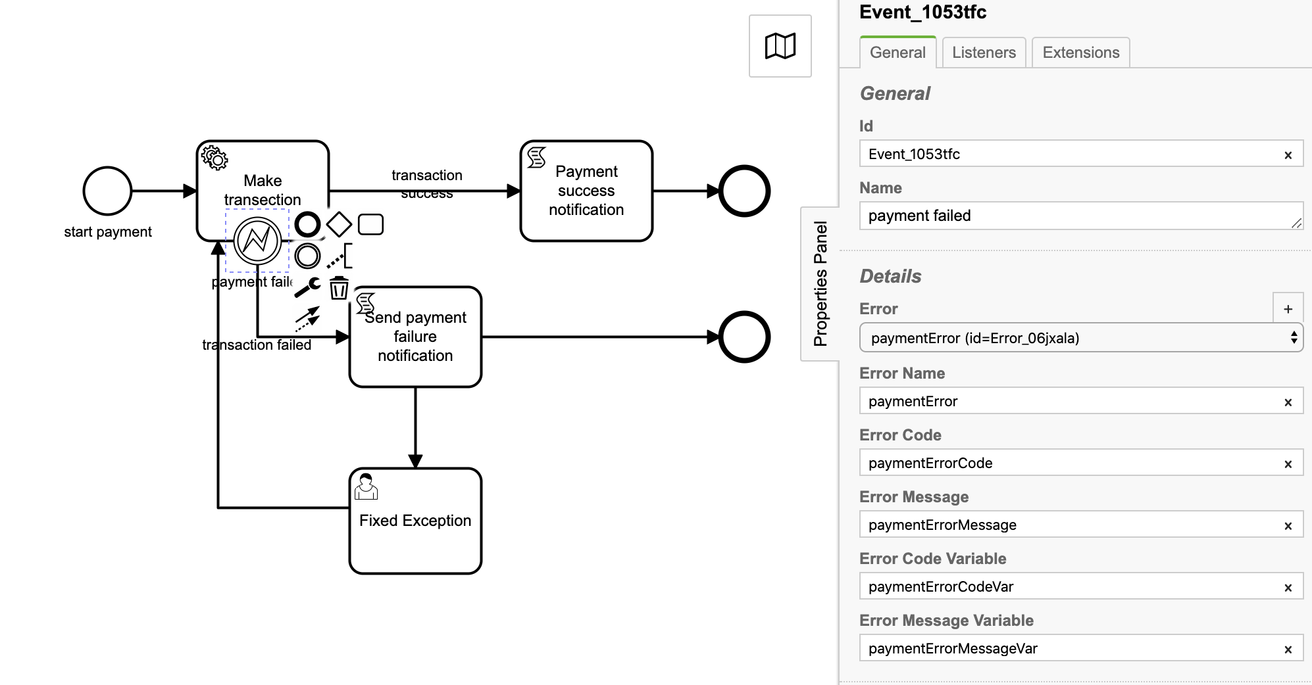
Boundary error event: payment failed
Id: Event_1053tfc
Name: payment failed
Error: paymentError (id=Error_06jxala)
Error Name: paymentError
Error Code: paymentErrorCode
Error Message: paymentErrorMessage
Error Code Variable: paymentErrorCodeVar
Error Message Variable: paymentErrorMessageVar

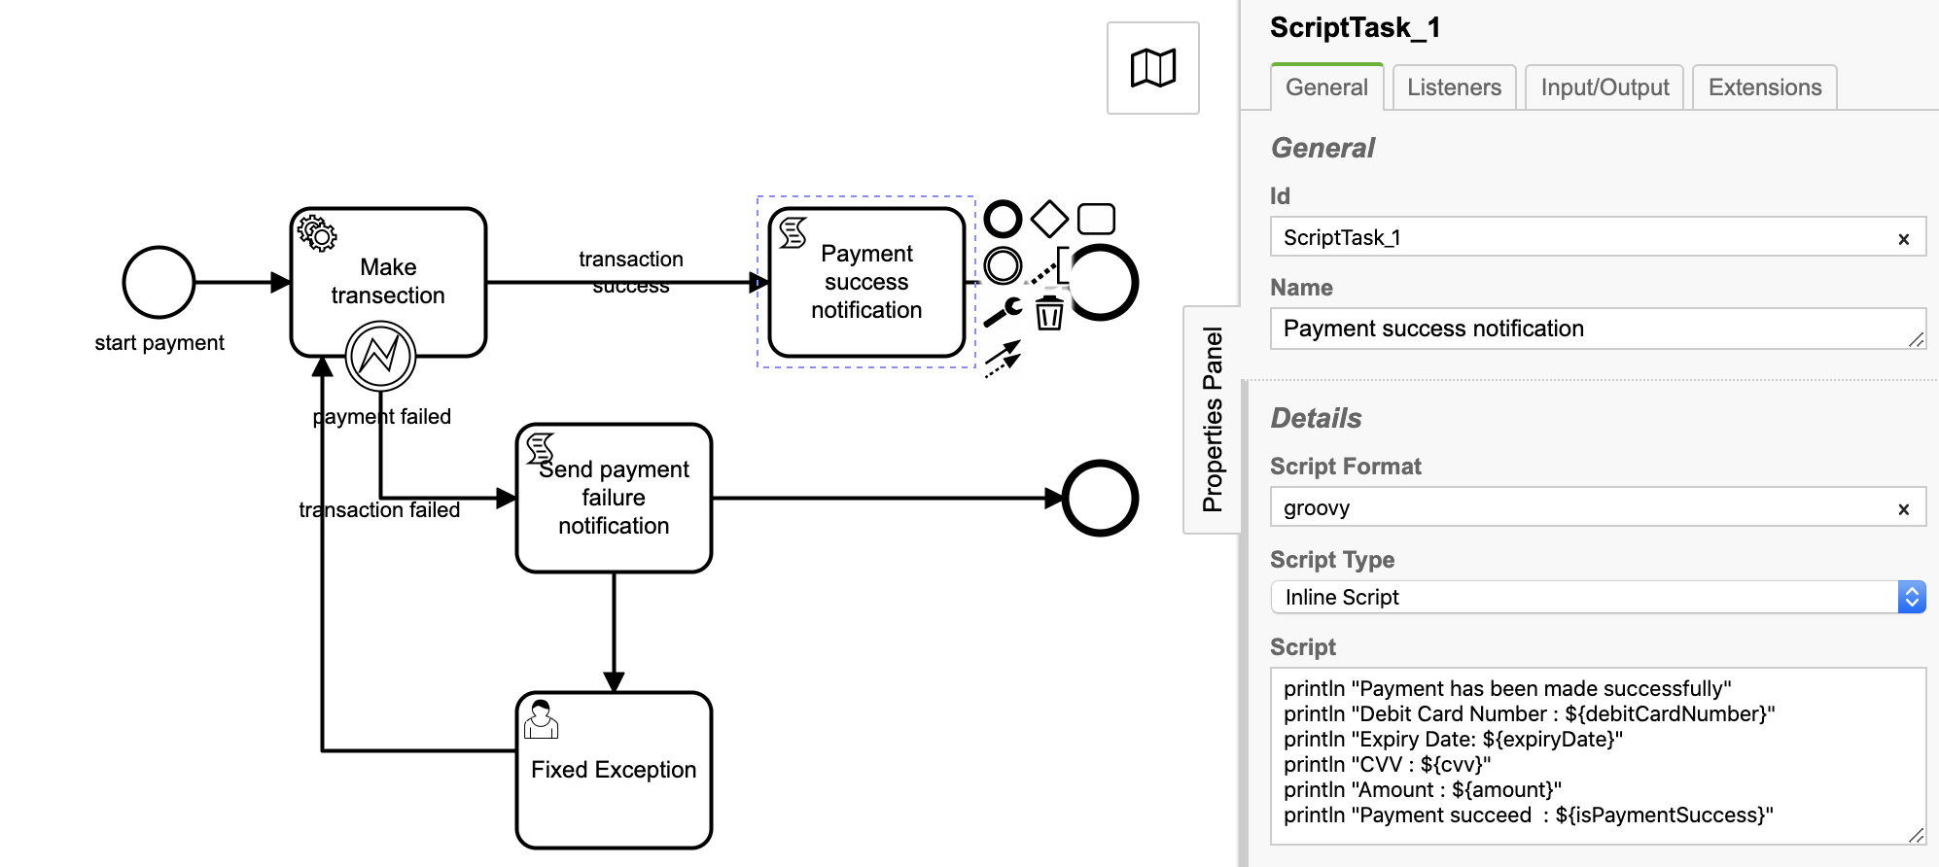
Script task: Payment success notification
Id: ScriptTask_1
Name: Payment success notification
Script Format: groovy
Script Type: Inline Script
Script:
println "Payment has been made successfully"
println "Debit Card Number : ${debitCardNumber}"
println "Expiry Date: ${expiryDate}"
println "CVV : ${cvv}"
println "Amount : ${amount}"
println "Payment succeed : ${isPaymentSuccess}"

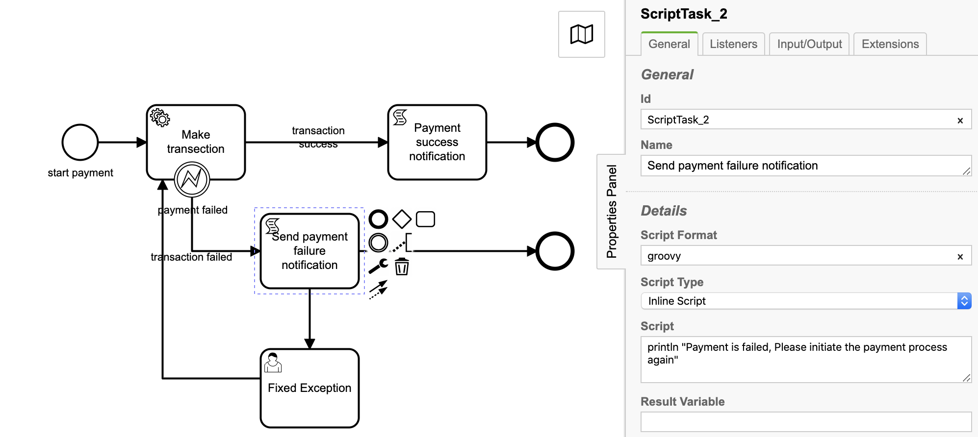
Script task: Send payment failure notification

Id: ScriptTask_2
Name: Send payment failure notification
Script Format: groovy
Script Type: Inline Script
Script:
println "Payment is failed, Please initiate the payment process again”

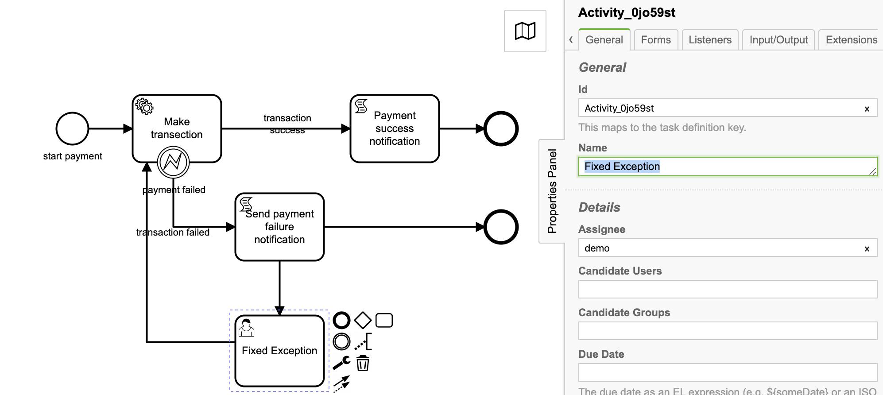
User task: Fixed Exception
Id: Activity_0jo59st
Name: Fixed Exception
Assignee: demo

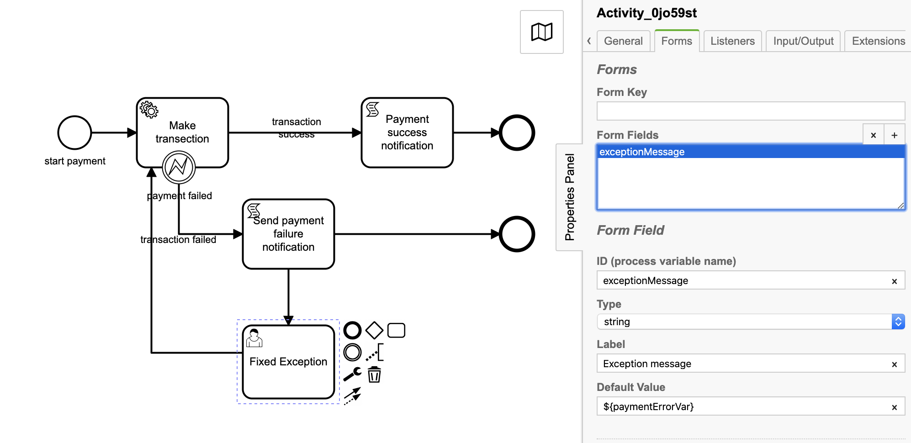
Task form

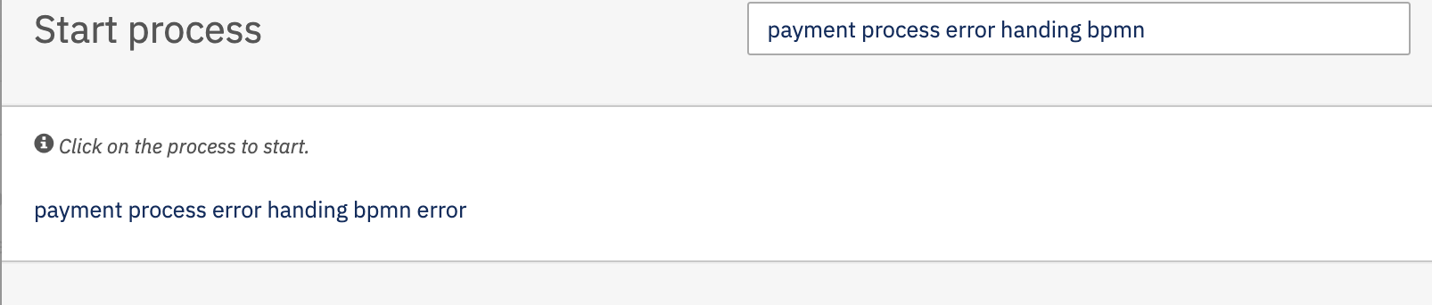
Build and deploy the process application. Start the process.

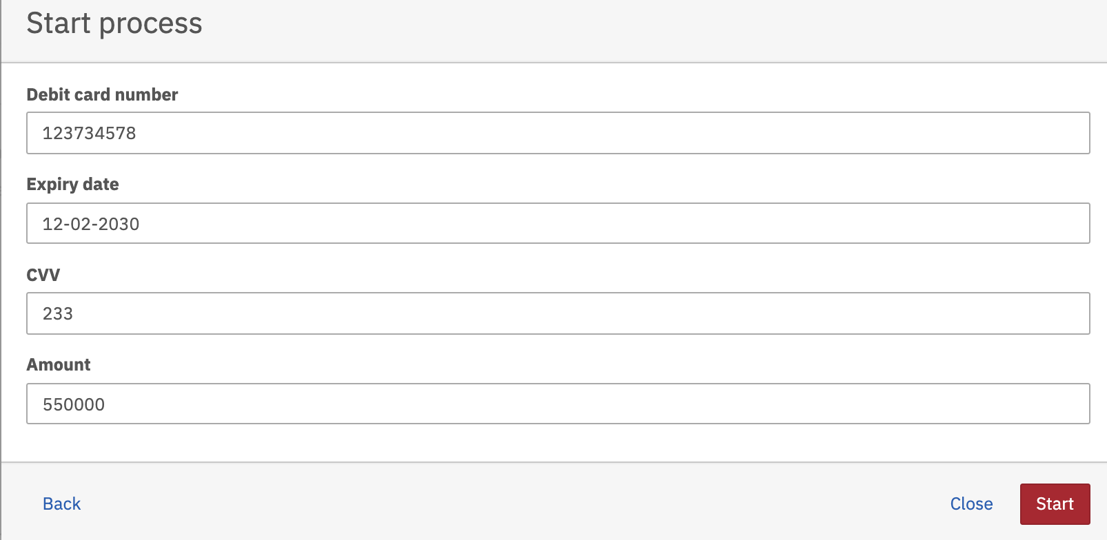
Hit the payment process error handling bpmn error

Fill-up the form and hit the Start button.

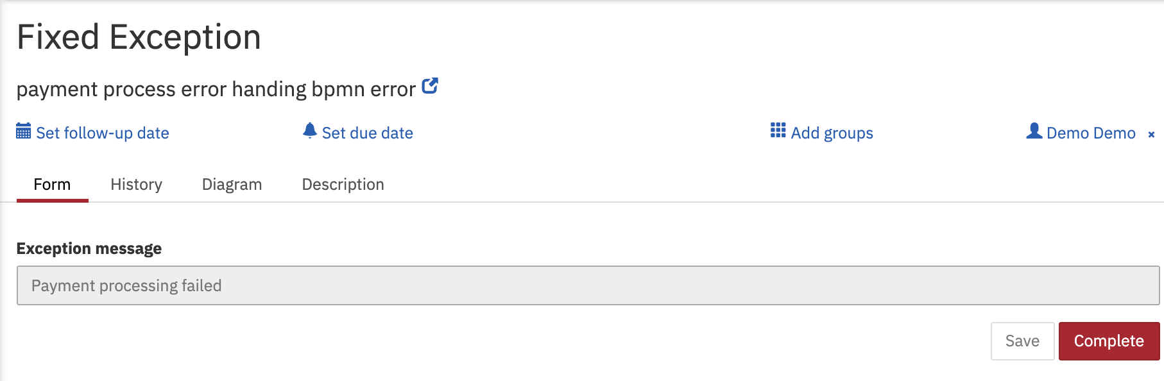
As per process definition service task will execute and it will throw error and will be handle through boundary error event and then user task Fixed Exception will get created.
Observe the tomcat console output
06-Sep-2020 22:05:43.650 INFO [http-nio-8081-exec-115] com.camunda.training.service.PaymentErrorHandlingDelegate.execute debitCardNumber : 123734578
06-Sep-2020 22:05:43.650 INFO [http-nio-8081-exec-115] com.camunda.training.service.PaymentErrorHandlingDelegate.execute expiryDate : 12-02-2030
06-Sep-2020 22:05:43.650 INFO [http-nio-8081-exec-115] com.camunda.training.service.PaymentErrorHandlingDelegate.execute cvv : 233
06-Sep-2020 22:05:43.650 INFO [http-nio-8081-exec-115] com.camunda.training.service.PaymentErrorHandlingDelegate.execute amount : 550000
06-Sep-2020 22:05:43.650 INFO [http-nio-8081-exec-115] com.camunda.training.service.PaymentErrorHandlingDelegate.execute Error occured or payment failed
Payment is failed, Please initiate the payment process again

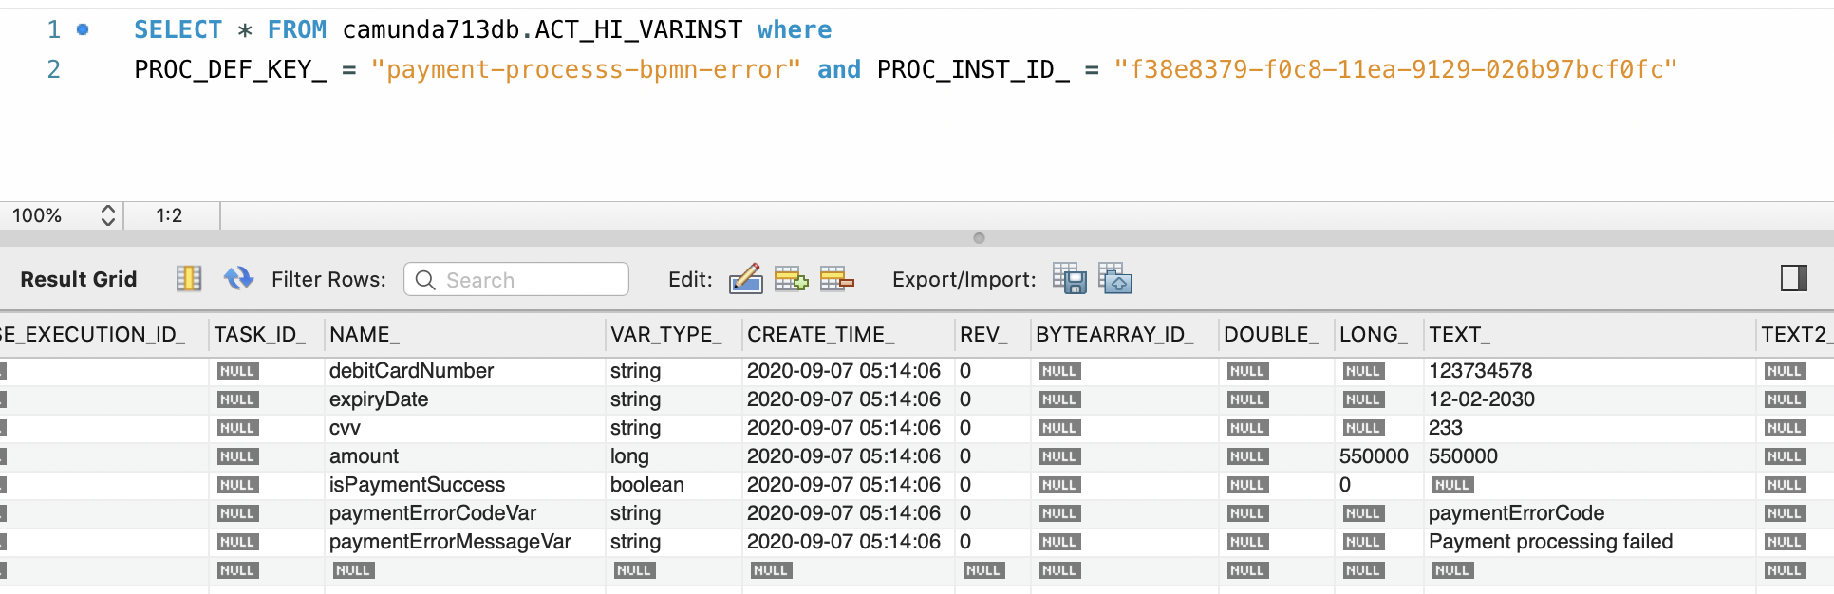
Observe the database table

